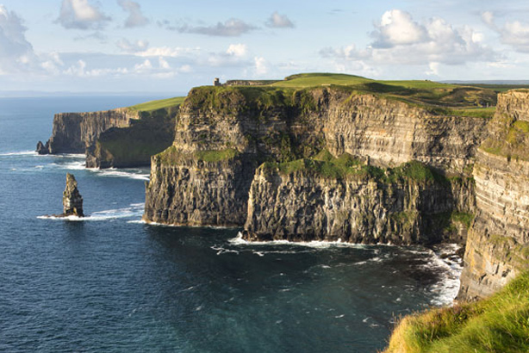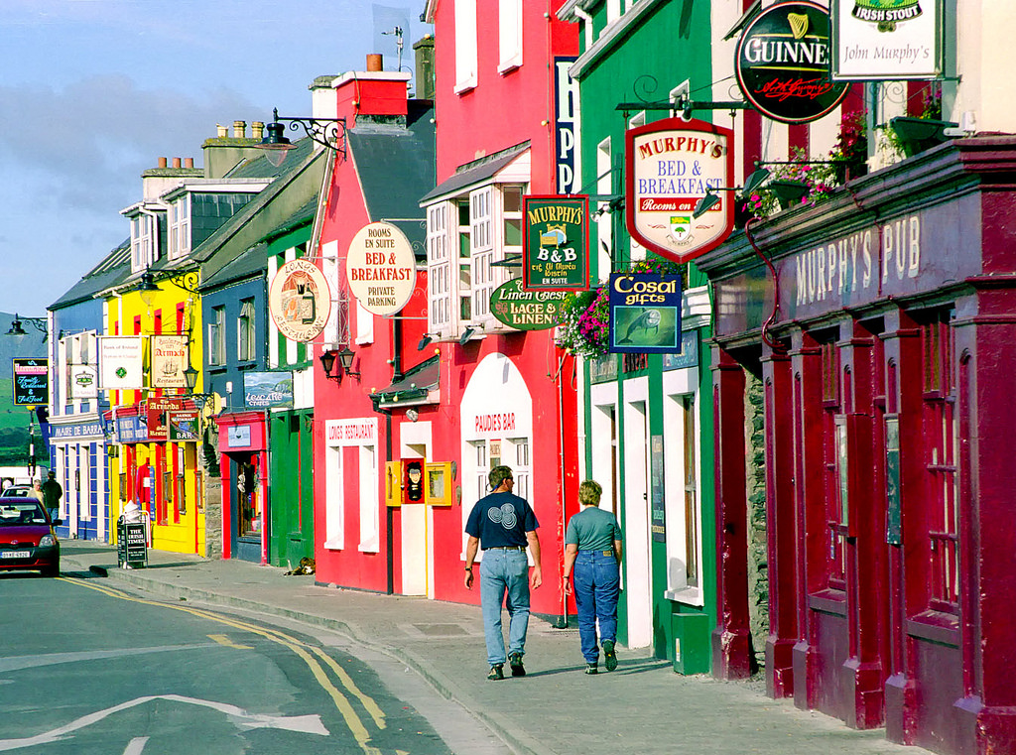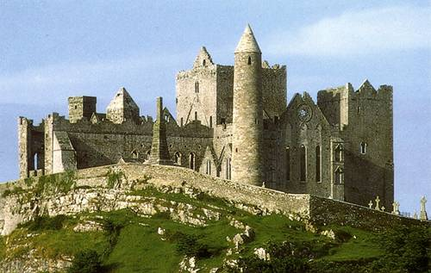

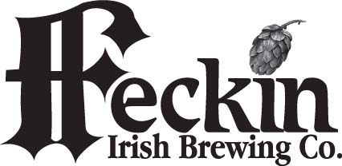
PUB & BREWERY TOUR OF IRELAND
JUNE 8 – 18, 2018
$2,085.00 PER PERSON (land only)

Fri 8th Overnight flight to Dublin. (Fares not available until Aug. 2017)

Sat. 9th Arrive in Dublin in the early morning where your driver will be waiting for you. Once on the coach the first stop will be for a Traditional Irish Breakfast at the Man O’War Pub, a pub that dates back to the year 1595. After breakfast you will have a panoramic city tour of Dublin before you make a visit to the Guinness Storehouse for a tour. The remainder of the afternoon is free and tonight you will meet for dinner at your hotel. (B & D) Ashling Hotel, Dublin

Sun. 10th You depart Dublin this morning and begin your journey south and west. Your first visit will be at the amazing Rock of Cashel. After a walking tour and a stop for lunch we will continue on to Mitchelstown and visit the Eight Degrees Brewery to sample their beer. The final destination today is the great little town of Clonakilty where you will have the remainder of the afternoon and evening at leisure to explore its pubs and restaurants. (B) Clonakilty Hotel, Clonakilty

Mon 11th The first stop today is to sample some whiskey and learn its history in the town of Midleton at the Jameson Distillery. Today is also a great day for some shopping and a chance to climb to the top of Blarney Castle to kiss the “magical stone”. It’s then back to Clonakilty with the remainder of the evening at leisure. (B ) Clonakilty Hotel,

Tue 12th After breakfast you depart Clonakilty and head for the west coast to the Dingle Peninsula with many photo stops and detours along the way. The afternoon is free to walk around this great town. Tonight you will meet for dinner in your lovely hotel. (B & D) Skelligs Hotel, Dingle

Wed. 13th Today you will enjoy the breathtaking drive out to Slea Head at the end of the peninsula, again with plenty of photo opportunities along the way. It’s back to Dingle town to explore all of the pubs and restaurant’s and don’t forget the Dingle Brewing Company. (B) Skelligs Hotel

Thur. 14th So long to Dingle as you board the Ferry to cross the River Shannon. Once into Co. Clare you will visit the majestic Cliffs of Moher where you will have an opportunity to do some climbing and get some great photos. Your final destination today is the town of Ennis. It’s a great city for traditional music so check out the pubs tonight. Templegate Hotel, Ennis (B)

Fri. 15th The journey today takes you through the beautiful rocky region of The Burren. On the way you will make a stop at Caherconnell where a local farmer will put on a demonstration with his three border collies and sheep. Your final destination is the quaint town of Westport where you will enjoy dinner together tonight in your hotel. Hotel Westport (B & D)

Sat. 16th Today you have an option of staying in Westport for the day to explore it’s shops and pubs, or the bus will leave for Galway city (with stops along the way) for a free day of exploring. Tonight is an evening in Westport to enjoy the pubs and restaurants. Hotel Westport (B)

Sun 17th After breakfast it is straight back to Dublin. Here you will have the option of a wonderful and very informative tour of Glasnevin Cemetery, where many of Ireland’s hero’s are buried or others may just want free time to explore all that this great city has to offer. Tonight you will enjoy a farewell dinner at your lovely hotel. Celbridge Manor Hotel, (B & D)

Mon 18th Sadly your journey together has come to an end. Your driver will get you to the airport in plenty of time for checking in and any last minute Duty Free shopping.

Land Only Price: $2,085.00 per person sharing based on a minimum of 20 people traveling. If we do not reach the minimum of 20 a price adjustment will become necessary. Airfare will not be available until August 2017.

Single Supplement: is available for an additional $275.00 (limited number available)

Trip Insurance is available for $202.00 per person and must be paid with initial deposit.

Price Includes: 9 nights accommodations at 3 & 4 star hotels, transport by deluxe motor coach with driver/guide throughout, full Irish breakfast each day, 4 dinners, all taxes and surcharges, porterage of ONE suitcase, portfolio of travel documents.

Visits & Admissions: Man O’War Pub breakfast, Guinness Brewery, Glasnevin Cemetery, Blarney Castle, Ferry across the Shannon, Cliffs of Moher, Caherconnell sheepdog demo, Jameson Distillery, Rock of Cashel, Eight Degrees Brewery, Slea Head & Burren scenic drives

Not Included: Airfare, Trip Insurance, Tip to your driver (recommended $13-$14 per day per person)

Deposit: A deposit of $500 per person is due immediately to secure a place. $100 becomes non-refundable after final payment is made. Space is limited so don’t delay as this tour will fill up quickly.

FINAL PAYMENT IS DUE BY APRIL 7, 2018

CHECKS ONLY FOR DEPOSIT PLEASE!
Make payable to: Tours Galore and mail to:
8961 Lake Dr. #303 Cape Canaveral, FL 32920

FOR FURTHER INFORMATION PLEASE CONTACT:
Mary Nolan 321 212 8182 info@toursgalore.net
Registration form can be downloaded on line: www.toursgalore.net

Tours Galore is a Licensed Seller of Travel Reg. No. 21830
CLIA Member 00508384 Tour No. FT618

Price is based on estimated exchange rates. Should a radical change occur a price adjustment may become
necessary. This itinerary is subject to change due to weather conditions or the discretion of your driver.

